Silver Tree Primary School and Nursery

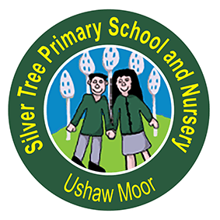

English Policy

Date of Policy | September 2023
Review Date | September 2024
Chair of Governor’s signature | A signed copy is available from the school office
Head Teacher’s signature | A signed copy is available from the school office

Contents

The Contribution of English to the School’s Curriculum...........................................................3

Statutory Requirements............................................................................................................3

Equal Opportunities..................................................................................................................3

Curriculum Delivery...................................................................................................................4

Approaches to Oracy…………………………......................................................................................4

Approaches to Phonics..............................................................................................................5

Approaches to Reading.............................................................................................................6

Approaches to Writing..............................................................................................................9

Approaches to Spelling............................................................................................................11

Approaches to Handwriting.....................................................................................................12

Assessment……………………………...............................................................................................13

Inclusion..................................................................................................................................14

The Role of Senior Leaders…………………..................................................................................14

Conclusion…………………………………………………………………………………………………………………………14

The Contribution of English to the School’s Curriculum

At Silver Tree Primary School, we recognise the crucial importance of studying the English language. Improved performance in speaking and listening, reading and writing will enable our pupils to express their thoughts and ideas more fluently, to engage more successfully with other curriculum subjects and will ultimately enrich their lives beyond school. The teaching and learning of language skills are, therefore, given a high priority in our school.

We have high expectations for our pupils and we encourage them to become independent learners and who strive to be confident in all areas of English. Our overarching aim is to promote high standards of language and literacy by equipping pupils with a strong command of the spoken and written word, and to develop their love of literature.

To achieve this, we aim for our pupils to:

- read fluently and with good understanding
- develop the habit of reading widely and often, both for pleasure and information
- acquire a wide vocabulary, an understanding of grammar and knowledge of linguistic conventions for reading, writing and spoken language
- write clearly, accurately and coherently, adapting their language and style in and for a range of contexts, purposes and audiences
- use discussion in order to learn; they should be able to elaborate and explain clearly their understanding and ideas
- be competent in their speaking and listening so that they are able to make formal presentations, demonstrate their ideas to others and participate in debates

Statutory Requirements
Statutory requirements for the teaching and learning of English are laid out in the National Curriculum in England: Framework Document (2014).

Equal Opportunities

All children are provided with equal access to the English curriculum. We aim to provide suitable learning opportunities regardless of gender, ethnicity or background.

Curriculum Delivery
From Nursery through to Year 6, children are taught English within their classes. Through differentiation and the support of teaching assistants, all children receive high quality teaching and appropriate support in order to reach their full potential. Children may receive additional support or intervention if necessary outside of the English lessons. Children that have a ‘Support Plan’ will receive intervention that focuses on their specific individual needs.

A clear lesson objective is a feature of all English lessons. Working walls may support learning in the classrooms. Evaluative marking is used. Assessment informs planning and reference is made to the National Curriculum in medium term plans. The use of computing enables children to use and apply their developing skills in English in a variety of ways. We encourage children to use technology as a resource for learning whenever appropriate to develop digital literacy skills.

Class novels are used to inspire and enthuse our children as they provide a rich and varied experience for pupils to draw on in their writing and reading throughout the curriculum.

Approaches to Oracy
At Silver Tree Primary School, we believe that effective communication is a fundamental skill that empowers our students to succeed academically, socially, and professionally. Through a well-rounded oracy approach, we aim to nurture confident, articulate, and empathetic individuals who can express themselves fluently and engage in meaningful conversations.
Our vision for oracy includes the following key elements:
1. Developing Speaking and Listening Skills: We recognise the importance of providing opportunities for students to practice and refine their speaking and listening skills. Our curriculum will incorporate various activities such as debates, presentations, role-plays, and group discussions to encourage active participation and effective communication.
2. Building Vocabulary and Language Fluency: We understand that a rich vocabulary and fluency in language are essential for effective communication. We will focus on expanding students' vocabulary through regular exposure to a wide range of texts, discussions, and word games. We will also encourage students to use language creatively and expressively, fostering their ability to articulate their thoughts and ideas clearly.
3. Promoting Critical Thinking and Reasoning: Oracy skills go beyond mere communication; they also involve critical thinking and reasoning abilities. We will incorporate activities that encourage students to analyse, evaluate, and construct arguments. We will provide opportunities for students to express their opinions, support their claims with evidence, and engage in respectful debates, fostering their ability to think critically and communicate persuasively.
4. Fostering Active Listening and Empathy: Effective communication is a two-way process that requires active listening and empathy. We aim to emphasize the importance of attentive listening skills, teaching students to listen actively, ask relevant questions, and respond thoughtfully. We will also encourage students to develop empathy by actively considering others' perspectives and experiences, promoting a respectful and inclusive learning environment.
Our vision aims to equip our students with the necessary skills to thrive in an increasingly interconnected and diverse world. We believe that by nurturing confident and articulate communicators, we are empowering our students to become active participants in society, capable of expressing themselves, understanding others, and making a positive impact in their communities.

Approaches to Phonics
The teaching of phonics is embedded within English teaching in each class. Additional provision is made in the EYFS and Key Stage 1 each day in discrete phonics sessions. These comprise of learning different graphemes, focussing on oral and aural phonological skills and sight vocabulary. During these sessions, children are also explicitly shown how to apply their developing skills to their writing. All pupils are introduced to new GPCs simultaneously, with some children having additional intervention to support development and progress.
At Silver Tree Primary School and Nursery we teach Phonics using a DfE validated Systematic synthetic phonics programme called ‘Rocket Phonics’.
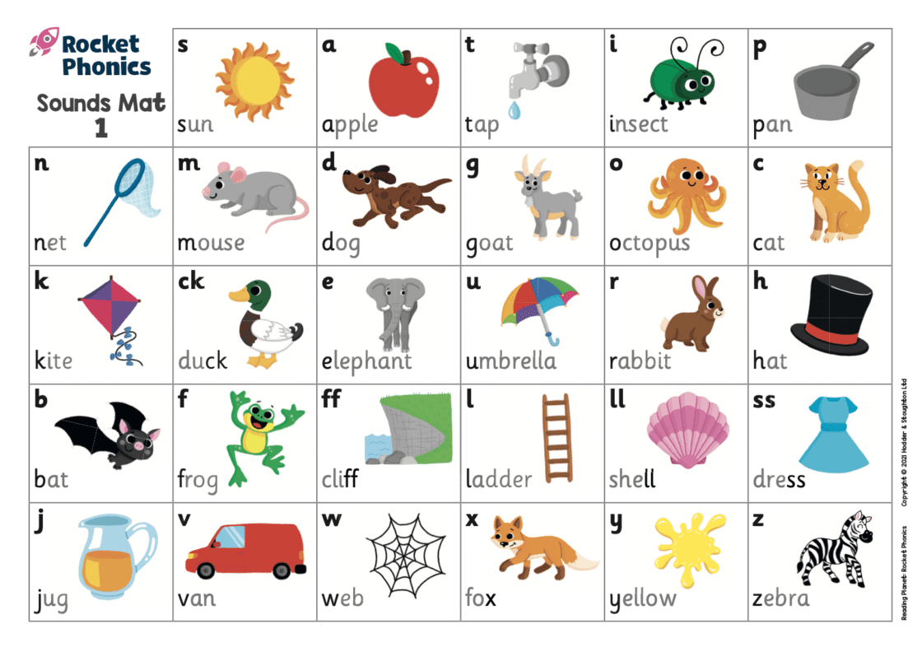
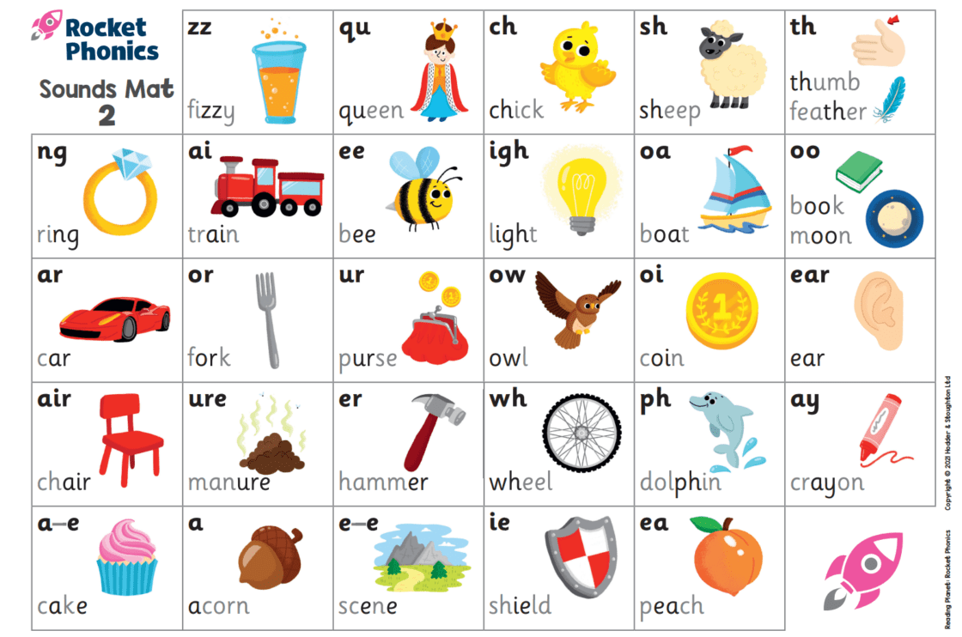

Children are taught:
- to see the letters and say the sounds for reading
- to hear the sounds and recall the letters for spelling
- blending for reading (oral, modelled, supported and independent blending at word, sentence and text levels)
- segmenting for spelling (oral, modelled, supported segmenting, knowing which spelling alternative to use)
- the skill of handwriting (pencil hold, letter formation, position on a writing line).
Children are also taught to recognise and write ‘common exception’ words gradually throughout the programme. These are words that cannot be sounded out e.g the, no, said, was.
Each lesson has 4 parts:
- Revisit and Review– Flashcards are used to revise previously taught sounds.
- Teach– Children are taught a new letter-sound correspondence. They are taught to form letters accurately.
- Practise– Children practise blending for reading and segmenting for spelling. Initially, this is done at word level, then sentence and text levels (when appropriate).
- Apply– Children apply their knowledge and transfer their skills in continuous provision (in Reception), in English and wider curriculum lessons in Key stage 1 and beyond.
Children practise, apply and consolidate their phonics skills and knowledge during weekly ‘Guided Reading’ sessions in school. Fully decodable texts are sent home (these contain only sounds/common exception words which have been taught previously) for the children to practise their phonics skills with their parents or carers. Children are encouraged to re-read books from the earliest stage to practise and improve their fluency (the ability to read with speed, accuracy and expression).
Approaches to Reading

Our approach to selecting reading books for pleasure, aims to foster a love for reading, encourage exploration, and cater to the diverse interests and reading levels of our students. This approach recognizes that reading for pleasure is essential for developing literacy skills, expanding vocabulary, and nurturing a lifelong habit of reading.

Students are provided opportunities to select books from our well-stocked library which consists of a wide range of books across various genres, themes, and caters for all abilities. Our library is organized in a way that allows students to easily browse and select books that pique their interest. Teachers will guide students towards books that match their reading abilities. Teachers are given license to restock and recommend books based on popular trends, award-winning titles, or student recommendations.

Our approach to reading includes:

- dedicated, non-negotiable, class novel/ story time 4 x 20 minute sessions per week
- independent reading 5 x 20 minute sessions per week
- Book Club 1 x 20 minutes per week
- opportunities for reading in all areas of the curriculum
- home reading – a minimum of three times per week
- Reading records which are monitored weekly to ensure reading is taking place at home

A diverse range of reading books is available in school and in individual classrooms. Electronic texts are also available from Reading Planet for shared reading. In EYFS and Key Stage 1, pupils read fiction and non-fiction books from Rocket Phonics as part of their guided and independent home reading. When pupils are ready to progress, they are encouraged to begin to select books which interest them, to help foster a love for reading.

In weekly reading lessons, children are explicitly taught the skills of reading (as outlined in the 2014 National Curriculum and the Key Stage 1 and 2 test domains) through the use of class novels, engaging stimuli such as video clips and high quality images and reading VIPERS.

VIPERS is an acronym which was created by The Literacy Shed to aid the recall of the six reading domains in the National Curriculum. They are the key areas that children need to understand in order to make progress with their reading comprehension.

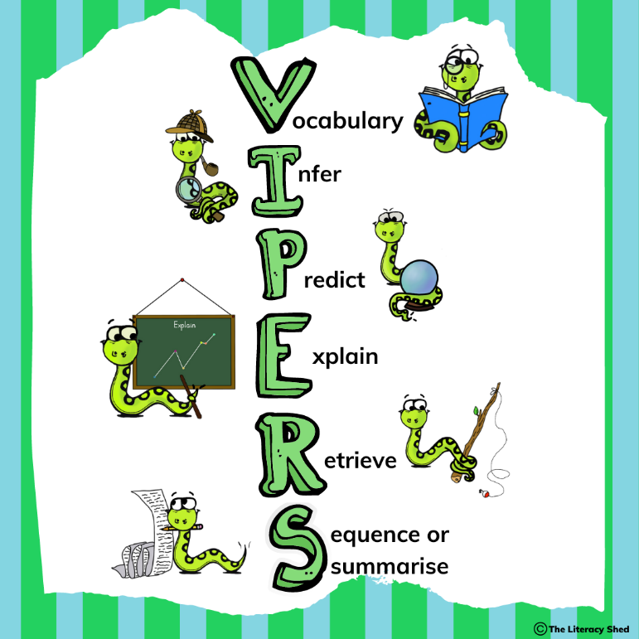

In Key Stage 1, the S stands for ‘Sequence’ and in Key Stage 2 it stands for ‘Summarise’. Additionally, in Key Stage 1, ‘Explain’ is not one of the content domains. Instead, it is used to challenge more able pupils to explain why they have come to a certain conclusion or to explain their preferences, thoughts and opinions about a text.

Key Stage 1 Content Domain Reference |  | Relevant VIPERS skill
1a | Draw on knowledge of vocabulary to understand texts | Vocabulary
1b | Identify/ explain key aspects of fiction and non-fiction, such as characters, events, titles and information | Retrieve
1c | Identify and explain the sequences of events in texts | Sequence
1d | Make inferences from the text | Infer
1e | Predict what might happen on the basis of what has been read so far | Predict
In Key Stage 2, ‘Explain’ covers the additional content domains of 2f, 2g and 2h.

Key Stage 2 Content Domain Reference |  | Relevant VIPERS skill
2a | Give/explain the meaning of words in context | Vocabulary
2b | Retrieve and record information/ identify key details from fiction and non/fiction | Retrieve
2c | Summarise main ideas from more than one paragraph | Summarise
2d | Make inferences from the text/ explain and justify inferences with evidence from the text | Infer
2e | Predict what might happen from details stated or implied | Predict
2f | Identify/ explain how information/ narrative content is related and contributes to meaning as a whole | Explain
2g | Identify/explain how meaning is enhanced through choice of words and phrases | Explain
2h | Make comparisons within a text | Explain

In Upper Key Stage 2, children’s explanation skills are also developed through their written responses to comprehension questions with the acronym PEE: Point Evidence Explanation.
Support staff are deployed throughout the school to work with children in order to improve their fluency, intonation, decoding skills and comprehension. Home reading is encouraged and is an integral part of the child’s development. In order to have strong communication between teachers and parents/ carers, each child has a reading record where both the staff and parents can write comments about how the child is progressing with their reading.
Teachers give children the opportunity to use books from Durham Learning Resources for independent research and enrichment. Events such as World Book Day and Roald Dahl Day are celebrated within school each year and pupils and parents are invited to annual events such as our Poetry Recital and an outdoor ‘Reading Picnic’ on the school field.

Approaches to Writing

At Silver Tree Primary School, we believe that developing strong writing skills is essential for our students' academic success and future endeavours. We teach key writing skills by supporting our pupils to write for a variety of purposes and providing daily time to write. Our approach to teaching and assessing writing skills aims to provide a consistent and effective learning experience for all students.
Aims:
1. To foster a love for writing and encourage students to express their thoughts, ideas, and creativity through written communication.
2. To develop students' ability to write clearly, coherently, and with appropriate grammar, punctuation, and spelling.
3. To equip students with the necessary skills to write for different purposes and audiences, including narrative, persuasive, descriptive, and informative writing.
4. To promote critical thinking and problem-solving skills through writing tasks.
5. To provide opportunities for students to receive constructive feedback and improve their writing through regular assessment and targeted support.
Teaching and Learning Strategies:
1. Teachers will provide explicit instruction on various writing genres, including modelling and shared writing activities.
2. Students will engage in regular independent writing tasks, allowing them to practice and apply the skills taught.
3. Adapted instruction will be provided to cater to the diverse needs and abilities of students.
4. Teachers will incorporate a range of resources, including books, digital media, and real-life examples, to enhance students' understanding and engagement with writing.
5. Collaborative writing activities will be encouraged to promote peer learning and collaboration.
Assessment and Feedback:
1. Student’s writing will be assessed as part of an ongoing cycle of formative and summative assessment. Writing across all genres will be used to gather evidence, and children will complete a minimum of two hot-writes per half-term.
2. Feedback will be provided to students, highlighting their strengths and areas for improvement.
3. Teachers will provide specific and actionable feedback to guide students' writing development.
4. Opportunities for self-assessment and reflection will be provided to encourage students to take ownership of their learning.
5. Progress in writing skills will be monitored and communicated to parents/guardians through assessment updates and parent evenings.
At Silver Tree Primary School, we have adopted and implemented the following writing process:
2. SPaG skills
Specific skills are initially taught in isolation then within context to support understanding of spelling, punctuation, and grammatical features.

- Model text / WAGOLL
A genre specific model text is shared with the children. A range of activities and talk opportunities are provided to evaluate and analyse the text.

4. Planning
Writing is planned to use a range of approaches which encourages collaboration and talk. This element also provides opportunities for shared writing.

3. Genre-specific skills
Children are taught genre-specific skills which could be used and applied to writing. Again, these are taught within context.

6. Editing
Children will be given the opportunity to edit and improve their writing following marking and feedback.
5. Writing
Using the skills they have been taught, children apply these to independent writing. Staff will provide live feedback where appropriate.

We aim to provide a comprehensive and engaging writing program that equips our students with the necessary skills to become confident and proficient writers. Through a collaborative effort between teachers, students, and parents/carers, we strive to nurture a lifelong love for writing and empower our students to communicate effectively in written form.

Approaches to Spelling
Knowing how to apply spelling rules and recognising key words is empowering for children. Spelling is a significant part of standardised assessment and is taught throughout school. We use the 2014 National Curriculum as a guideline as to which spellings should be taught in which year group.

The teaching of spelling in EYFS and KS1:

- From Nursery, children are introduced to the concept that words are broken down into sounds.
- Visual resources and images are displayed in classrooms to remind children of graphemes they want to write.
- Children in EYFS and Key Stage 1 have short, focused daily phonics sessions which systematically and sequentially teach the 40+ phonemes in the English language.
- This phonemic knowledge is then applied to the children’s reading and writing.
- Children learn actions, sounds and letter names through games and activities that support sounding out, segmenting and blending.
- Children are encouraged to have a go at writing by sounding out words and recording the sounds they hear.
- Sound and spelling mats are available for children to use to support their spelling
- From Year 1, children are actively encouraged and taught to proof-read their writing and to correct misspellings.

The teaching of spelling in Key Stage 2:

- Children carry out a minimum of three 20-minute spelling sessions per week, following Spelling Shed planning.
- Throughout Key Stage 2, a spelling rule or new spelling pattern is introduced weekly and relevant spellings are taught creatively in a variety of ways, for example through mnemonics, word sorting tasks, spelling games and approaches such as ‘Look, Cover, Write, Check’.
- Vocabulary word banks, high frequency word displays, dictionaries and spelling mats scaffold the children’s spelling as necessary.
- If misspellings are identified by adults when marking the children’s written work, pupils are given the opportunity to correct and practise the spellings as part of their response to marking and feedback.
- Where additional spelling support is needed, children work in small groups with an adult to reinforce spelling patterns and to identify the tricky sounds in common exception words.

Approaches to Handwriting
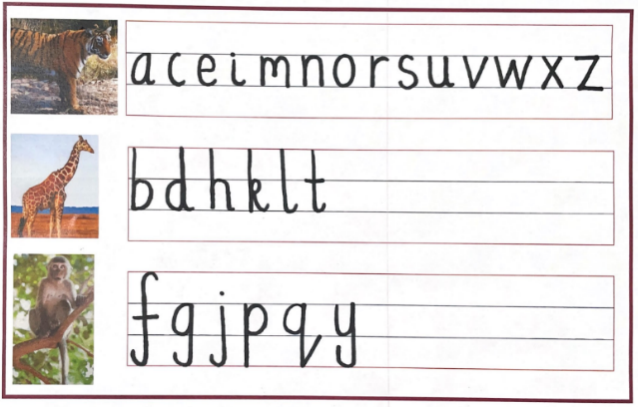
At Silver Tree Primary School, we recognise the importance of developing legible and fluent handwriting skills in our students. Our Progressive Handwriting Policy aims to provide a structured and progressive approach to handwriting instruction, starting from Nursery and continuing through to Year two and beyond. This policy outlines our approach to handwriting, including the introduction of cursive handwriting from Year two and the use of animal analogies to support the formation of ascenders and descenders.
Nursery
Pre-writing Skills: In Nursery, students will develop pre-writing skills and engage in activities that promote fine motor skills development, such as finger painting, tracing shapes, and using manipulatives. These activities will help students develop the necessary hand-eye coordination, fine-motor skills and muscle control required for handwriting.
Reception and Year One:
Introduction to Print Handwriting: In Reception, we aim to build on from the children’s experiences in Nursery, and aim to ensure all children can hold a pencil effectively using the tripod pencil grip. Students will be introduced to print handwriting following our systematic phonics scheme (Rocket Phonics) agreed letter formation mantras. They will learn to form letters using correct letter formation and, in Year 1, they will begin to concentrate on consistent sizing. Teachers will provide explicit instruction and modelling, allowing students to practice and refine their print handwriting skills.

Year Two:
Introduction to Cursive Handwriting: In Year two, students will be introduced to cursive handwriting. They will learn to connect letters within words, promoting fluidity and efficiency in their writing. Teachers will provide explicit instruction on cursive letter formation and guide students through practice exercises.
2. Use of Animals to Support Letter Formation: To support the formation of ascenders, descenders, and tiger letters, we will introduce the use of animals as visual cues. Giraffe letters (such as b, d, h, k, and l) will be associated with the image of a giraffe, emphasizing the tall ascenders. Monkey letters (such as f, g, j, p, q, and y) will be associated with the image of a monkey, highlighting the descending tails. Tiger letters (such as a, c, e, m, n, o, r, s, and u) will be associated with the image of a tiger, representing letters that have neither ascenders nor descenders.
Continued Practice and Refinement:
1. Regular Handwriting Practice: Handwriting practice will be incorporated into daily routines across the curriculum. Students will have dedicated time for handwriting exercises, allowing them to reinforce their skills and develop consistency in their letter formation.
2. Individualised Support: Teachers will provide appropriate feedback to support and guide students who require additional assistance with handwriting. This may include extra practice, modified instruction, or the use of adaptive tools to support their handwriting development.
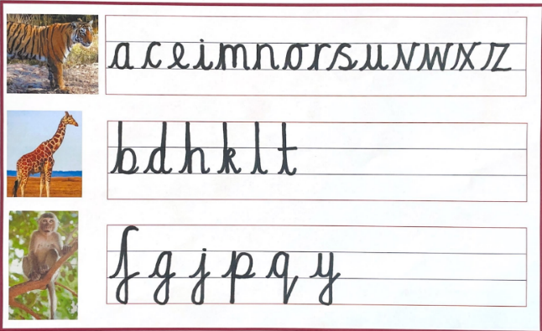
3. All classrooms will display our handwriting poster for reference and to support expectations.

The implementation of this handwriting policy will be monitored and evaluated through regular observations, student work samples, and feedback from teachers and students.

Assessment

Work is assessed in line with the Assessment Policy and feedback is given in line with the Marking and Feedback Policy.

Day to day in-school formative assessment allows teachers, pupils and parents/ carers to understand pupil performance on a continuing basis. A range of day-to-day in-school formative assessment strategies will be used to assess pupil progress in English, including:

- Staff will track pupils’ progress in reading, writing and spelling
- targeted questioning
- marking of pupils’ work, with positive feedback and development/ improvement areas highlighted
- observational assessments
- discussions with children
- pupil self-assessment and self-correcting using green polishing pens

In-school summative assessments will be used to monitor and support children’s performance. They will provide teachers, pupils and parents/ carers with information about pupils’ achievement, progress and wider outcomes. A range of in-school summative assessment strategies will be used to assess pupil progress in English, including:
- termly assessments using PIRA and GAPS tests
- termly phonics checks
- end of year annual reports outlining progress and attainment of children in relation to National Curriculum age related expectations

Nationally standardised assessments will be used to provide information on how children are performing in comparison to children nationally. These include a baseline assessment in Reception, the Phonics Screening Check in Year 1 and the SATs in both Year 2 and Year 6.

Inclusion

We are an inclusive school where all pupils are supported to make progress from their individual starting points and to achieve highly according to their individual abilities. Children with identified SEND receive tailored support in English from teachers and teaching assistants. Children who are identified as being in the lowest 20% of readers receive extra support from teachers, teaching assistants and volunteers who come into school to listen to the children read. More able children are also identified and challenged in English appropriately. In addition, the algorithm on Doodle English and Doodle Spell ensures that tasks and activities set on the apps are pitched at the right level for each individual child.

The Role of Senior Leaders

Senior Leaders are responsible for improving the standards of teaching and learning in English through the monitoring and evaluation of the subject. This will involve:

- monitoring pupil progress as well as the provision of English
- analysing data
- taking the lead in policy development
- auditing and supporting colleagues in their CPD
- purchasing and organising resources
- keeping up to date with recent English developments
- analysing the results of nationally standardised tests to identify areas for development
- checking that assessment for English is carried out in line with the school’s assessment policy
Conclusion

This policy should be read in conjunction with the following Silver Tree Primary School policies: Assessment Policy, Curriculum Policy, Early Years Policy, Equal Opportunities Policy, Marking and Feedback Policy and Special Educational Needs Policy.

