Silver Tree Primary School and Nursery
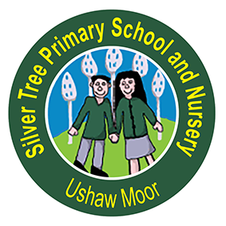

Mathematics Policy

Date of Policy | March 2021
Review Date | March 2023
Chair of Governor’s signature | A signed copy is available from the school office
Head Teacher’s signature



Calculation Policy Preface

At Silver Tree Primary School and Nursery, we have consistent approach to the teaching of Maths which begins in our Early Years setting and develops through to Year 6.
The main approach to Maths which we have adopted, is taken from White Rose Maths planning although we support this with other resources and approaches such as Doodle Maths to meet the varied needs of our children.
We use a range of models and teaching strategies to support the understanding of the different concepts of Maths. In all year groups, we ensure a consistent use of concrete, pictorial and abstract methods to support the fluency, reasoning and problem-solving skills in all areas of Maths.
As a school, we are aware that maths impacts all aspects of our lives and helps us to make sense of the world. With this in mind, this policy promotes the basic and wider understanding of Maths, and we hope that the children in our school will enjoy Maths and use the skills in their everyday lives.
All staff are trained in the key concepts of our approach to Maths to ensure the children are supported successfully in their understanding of key objectives.
Focused interventions are planned and monitored to support the needs of the children as well as to extend their understanding and offer challenges where needed. Interventions reflect the White Rose methods used through the main classroom teaching alongside Doodle Maths and personalised methods to meet the needs of the children. Children who join our school are supported to ensure they have a clear understanding of the methods we use in school to support their learning in the classroom.

- Appendix 1 – White Rose Maths – Addition and Subtraction Calculation Policy

- Appendix 2 – White Rose Maths – Multiplication and Division Calculation Policy

